WORK HISTORY

Webs Divine
June 2004 to present
http://deborahotoole.com/websdivine/
Chief web designer. Designs professional websites to client preference in regards to color and font schemes, size of site, specific themes and more. Ensures that templates have visual consistency by employing uniform fonts, formatting icons, images and layout techniques. Complete line of services include web design, logos and buttons, photo galleries, online stores, access management, contact forms, newsletters, documents, e-book conversion services, press releases, flyers and book covers.

Skills
Several years of word processing experience, graphics (creating images and flash photo galleries), web design and maintenance, accounting, inventory control, newsletter composition and design, e-book creation, design and conversion; accounts payable/receivable, collections, purchasing, ten-key, general office.

Debby has several years of experience in graphic creation, web design and maintenance, access management, online newsletter design and composition, and e-book creation, cover design and conversion. She has Knowledge of software programs and services for practical use in developing websites, articles, graphics, flyers, logos, newsletters, photo galleries, e-book and paperback covers, e-book conversions and press releases, including: Adobe (Dreamweaver, Fireworks, Photoshop, Pro); Anthropics (Portrait Pro, Landscape Pro, Portrait Pro Body, Smart Photo Editor); Apache Open Office (Writer, Calc, Impress, Draw, Base, Math); Blender (open-source software for 3D modeling, animation, rendering, post-production, interactive creation & playback), Blue Griffon (web & e-pub editor based on Firefox rendering engine), Calibre (multiple format e-book conversion program), Classic FTP (ftp program), Coffee Cup (Applets, Color Schemer, Firestarter, HTML Editor, Password Wizard, Photo Gallery, Shopping Cart, Visual Designer, Web Form Builder, Website Access Manager); Concrete5 (open source content management system), Corel Word Perfect Office, File Zilla (ftp program), Fam-Tree, Global Scape (Cute FTP); Kompozer (wysiwyg HTML editor), Lightscreen (screenshots), Microsoft Office (Digital Image Suite, Excel, Expression, Front Page, Money, Power Point, Publisher, Reader, Word, Works); Mobipocket Creator, PDF to EPUB, PDF to Word Converter, NCH Software (Express Menu Maker, Photo Pad, Photo Stage), PDF Pro, Picasa, Roots Magic 7 (genealogy software), Trellix, Win Zip and Wondershare Technology (Photophire, Gallery Factory, PDF Element, Video Converter).

Debby also has Knowledge and use of social media (Blogger, Blurb, Buzz Feed, Facebook, Fancy, Linked In, Pinterest, Scribd, Storify, Stumbled Upon, Tumblr, Twitter and YouTube) and online services (Amazon Author Central, Authorgraph, Barnes & Noble Nook Press, Bravenet, Cafe Press, Constant Contact, Dribble, Dropbox, E-Bay, Flickr, Flipsnack, Go Daddy, Good Reads, Kindle Direct Publishing, Kobo Writing Life, Library Thing, Lulu, PayPal, Smashwords and Tripod Lycos).

PUBLICATIONS
Nine published fiction novels (writing as Deidre Dalton) and one cookbook; five published fiction novels (writing as Deborah O’Toole); eleven short stories, one book of poetry, more than forty e-books on ethnic culinary traditions ("Food Fare Culinary Collection" writing as Shenanchie O’Toole) and thirteen cookbooks edited for Food Fare; former staff writer for Ambermont Magazine (online).

REFERENCES
Available upon request.

WEB DESIGN MINI-PORTFOLIO
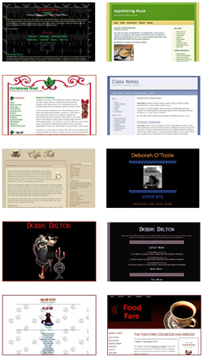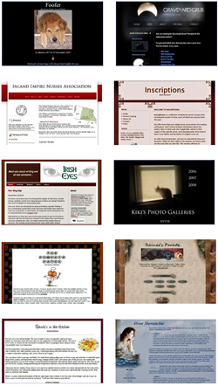

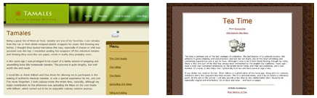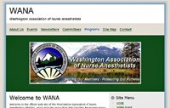

NEWSLETTER SAMPLES
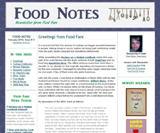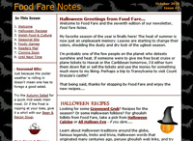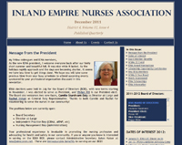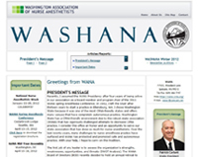

LOGO/BUTTON SAMPLES

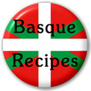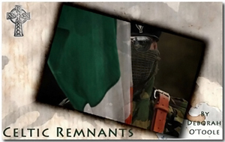

BOOK COVER DESIGN SAMPLES
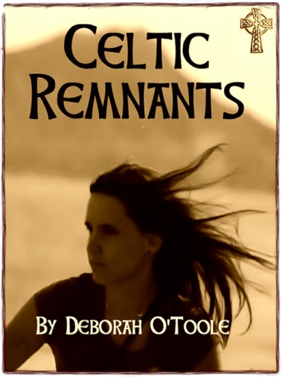

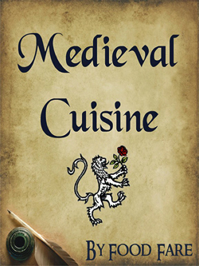

For more, go to Webs Divine at https://deborahotoole.com/websdivine/aboutwd.htm
Rev. 05/03/24

